An improved scheme for core point positioning

Step 1
Given an input image, I enhance [1] the fingerprint in order to obtain a better image quality.
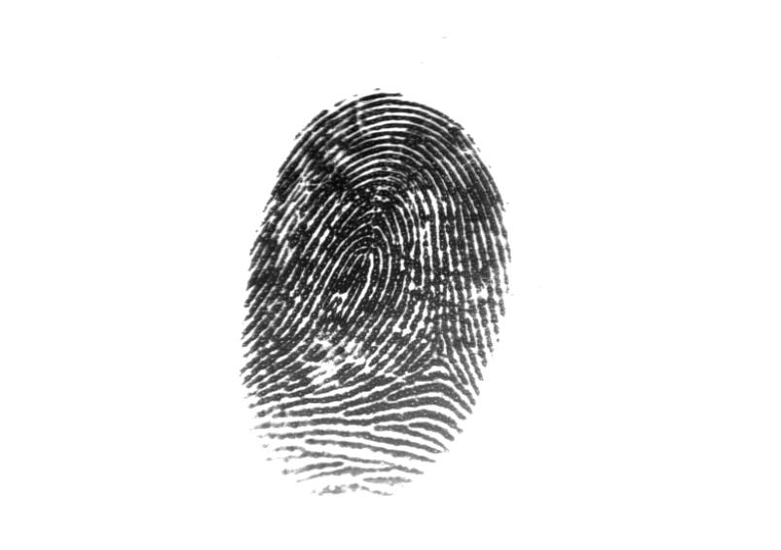
Figure 1. Input fingerprint image

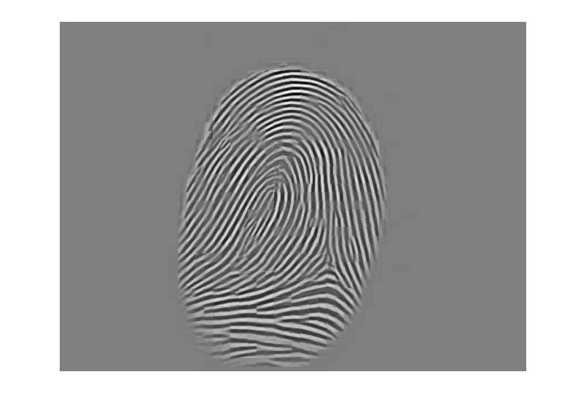
Figure 2. Enhanced fingerprint image

Step 2
After this operation, the image is segmented and background is separated from fingerprint image. This can be performed using a simple block-wise variance approach, since background is usually characterized by a small variance. Image is first binary closed (Matlab command imclose), then eroded (Matlab command imerode), in order to avoid holes in fingerprint image and also undesired effect at the boundary (between fingerprint and background). The image segmentation is repeated several times, up to a desired condition is satisfied. This is done in order to avoid undesired boundary effects between fingerprint and background. The condition which has to be satisfied is chosen in the following way: the enhanced image is divided into non-overlapping blocks of given sizes (usually 32 x 32 or 64 x 64). The whole enhanced image is filtered with a complex filter. Let Cf_max be the maximum value of the filtered image in the current region of interest (previously calculated according to some initial parameters). For each non-overlapping block we calculate the relative maximum Cf_rel. We finally consider a logical matrix F whose element (I,J) is equal to 1 if (I,J) is a block relative maximum and this value is equal or greater than a threshold value (usually 0.65*Cf_max in our simulations); F(I,J) is equal to 0 in all the other cases (i.e. if F(I,J) is not a block relative maximum or a block relative maximum smaller than the threshold value). If the number of non-zero elements of the logical matrix F is above a threshold value, the parameters for image segmentation are re-calculated and the whole process is repeated once again (complex filtering output does not vary, only the region of interest has been changed).

Note: these relative maxima larger than the threshold value are not considered core points but they will be considered candidates for it when a new image is selected for fingerprint matching.

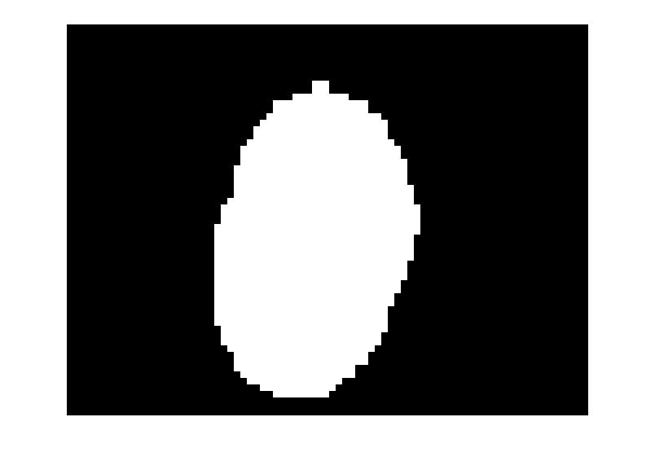
Figure 3. Image is segmented, closed and eroded (binary erosion and closing).

Step 3
Then we perform a fast pixel-wise orientation field computation [2].
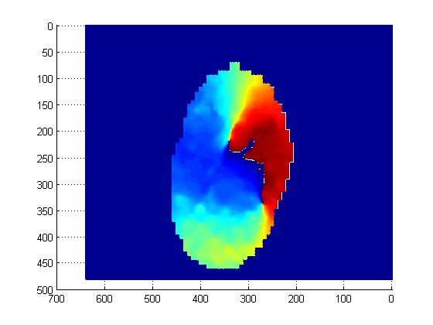
Figure 4. Pixel-wise orientation field estimation in the region of interest.

Step 4
The orientation field is used to obtain a logical matrix where pixel (I,J) is set to 1 if the angle of the orientation is <= PI/2 (PI 3.1415926535897...).



Figure 5. Logical matrix with local orientation field <= PI/2

Step 5
After this computation I find the border of this logical matrix, in the region of interest of fingerprint image.

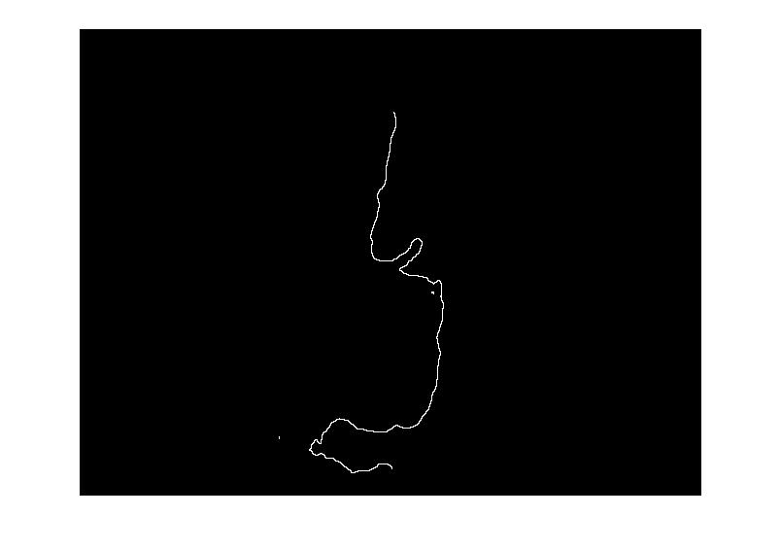
Figure 6. Border of the logical matrix in Fig.5 in the region of interest.

Step 6
After this computation I calculate the complex filtering output [3] of the enhanced fingerprint image. It is not necessary to re-calculate it, I use the complex filtered image calculated in step 2.

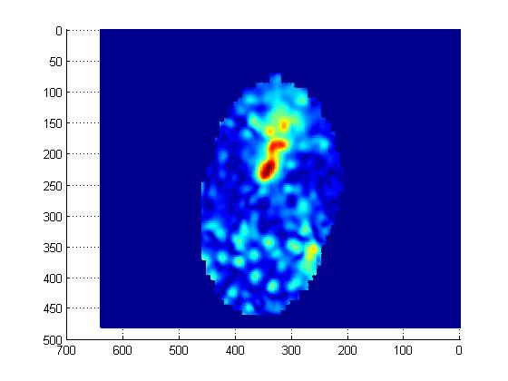
Figure 7. Complex filtering output of the enhanced fingerprint image.

Now I can find the maximum value of complex filtering output where the pixels of the logical image (shown in Fig. 6) are set to 1.

Step 7
I repeat steps 4-5-6 for a wide set of angles (…,PI/2-3*alfa, PI/2-2*alfa, PI/2-1*alfa, PI/2, PI/2+1*alfa, PI/2+2*alfa, PI/2 +3*alfa, …where alfa is an arbitrary angle). Each time I determine a point ( Note: each of them will be a candidate for fingerprint matching).

Step 8
I subdivide all the points found in step 7 into subsets of points which are quite near each other. I will have say N subsets. For each subsets I will have a certain number of candidates and I consider only subset with a number of candidates >= 3. For each of this subset I consider the subset with the greatest x-averaged coordinate. In this subset I consider the core point the candidate with the greatest x-coordinate. This is a good approximation in standard fingerprint image.

See supercore7.m for more details concerning the algorithm used. The functions supercore7_list returns as candidates for core point:
- The points found at the end of step 8
- The point found as relative maxima of non-overlapping block at the end of step 2

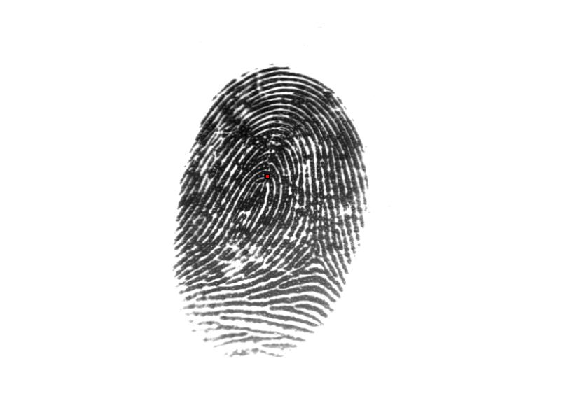
Figure 8. Input fingerprint image and corresponding core point.

References

[1] S. Chikkerur,C. Wu and Govindaraju, "A Systematic approach for feature extraction in fingerprint images", ICBA 2004
[2] Ravishankar Rao, "A taxonomy of texture description", Springer Verlag
[3] Kenneth Nilsson and Josef Bigun, “Localization of corresponding points in fingerprints by complex filtering”, Pattern Recognition Letters 24 (2003), 2135-2144

